Personalized Edge-AI Multimodal Health Monitoring with Missing Data Robustness for IoT Wearables

Implementation and Preliminary Experimentation Status Report

Student: Samra Iqbal

Student ID: 255129025

1. Introduction
This project aims to develop a personalized Edge-AI multimodal health monitoring system for IoT wearables. The primary objective is to detect stress using physiological signals collected from wearable sensors while maintaining robust performance even when some sensor data is missing or noisy. Such systems are highly relevant for real-time health monitoring, remote patient care, and intelligent wellness applications.
For this implementation phase, a working prototype was developed using the WESAD (Wearable Stress and Affect Detection) dataset. The prototype focuses on stress detection using multimodal physiological data and evaluates the system's resilience under missing-data conditions.

2. Dataset and Signal Selection
The WESAD dataset was selected because it provides high-quality multimodal physiological recordings collected from wearable and chest-mounted sensors. For this prototype, wrist-based data from Subject S2 was used.
The following physiological modalities were selected:
- Electrodermal Activity (EDA)
- Blood Volume Pulse (BVP)
- Heart Rate (HR)
These signals are strongly associated with stress and autonomic nervous system activity, making them suitable for affective state monitoring.
Dataset link: WESAD Dataset on UCI Machine Learning Repository
3. Methodology and Implementation

3.1 Data Preprocessing
The raw CSV files were loaded and cleaned. The first two metadata rows in each file (initial timestamp and sampling frequency) were removed. Since the sensors operate at different sampling rates, all signals were resampled to a unified frequency of 1 Hz to enable synchronization and multimodal fusion.
Original sampling rates:
- EDA: 4 Hz
- BVP: 64 Hz
- TEMP: 4 Hz
- HR: 1 Hz
After resampling, all modalities were aligned into a single synchronized dataset.

3.2 Feature Extraction
The synchronized signals were segmented into 60-second windows with 50% overlap. For each window, statistical features were extracted from each modality:
- Mean
- Standard Deviation
- Minimum
- Maximum
- Median
This resulted in 20 features per window (5 features × 4 modalities).

3.3 Baseline Classification Model
A Random Forest classifier was implemented as the baseline machine learning model. The extracted features were used to classify physiological states into two categories:
- Stress
- Non-Stress
The dataset was divided into training and testing sets using an 80:20 split.

Heart Rate Signal Visualization
The heart rate signal illustrates temporal variations in cardiovascular activity throughout the recording period. Noticeable fluctuations in heart rate can be observed during stress periods, reflecting the body's physiological response to increased mental or emotional load.
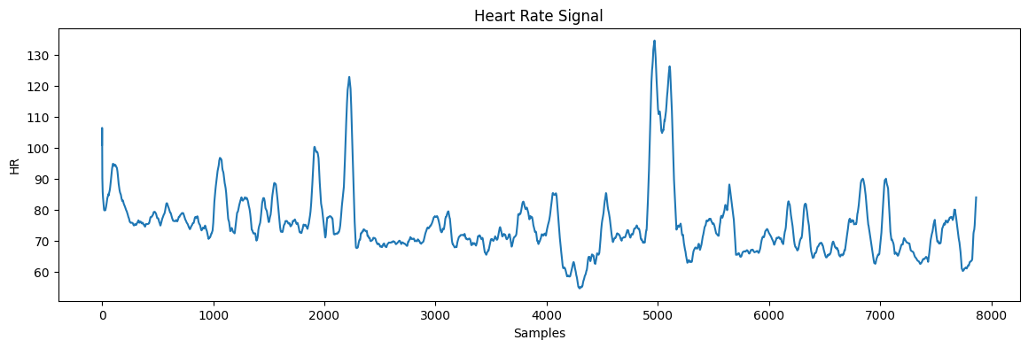

Blood Volume Pulse (BVP) Signal Visualization
The BVP signal captures changes in blood flow and vascular activity over time. Variations in amplitude and waveform patterns provide valuable information about cardiovascular dynamics and are highly informative for stress detection.
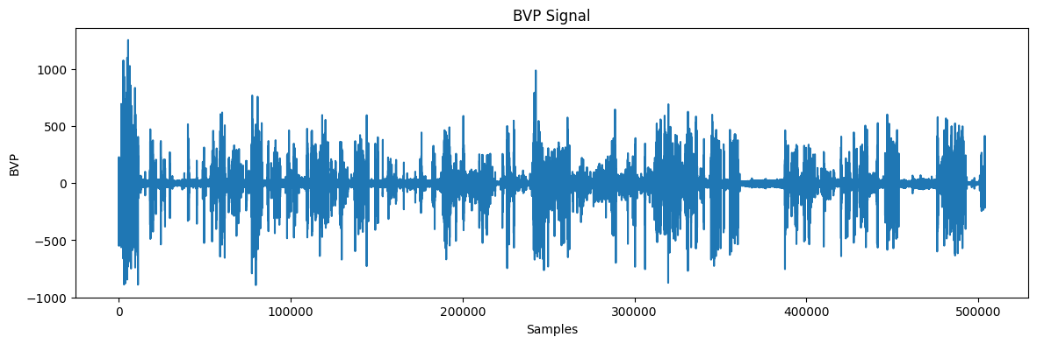

Electrodermal Activity (EDA) Signal Visualization
The EDA signal represents changes in skin conductance caused by sweat gland activity. Elevated EDA levels typically correspond to heightened sympathetic nervous system activation, making it one of the most important indicators of stress.
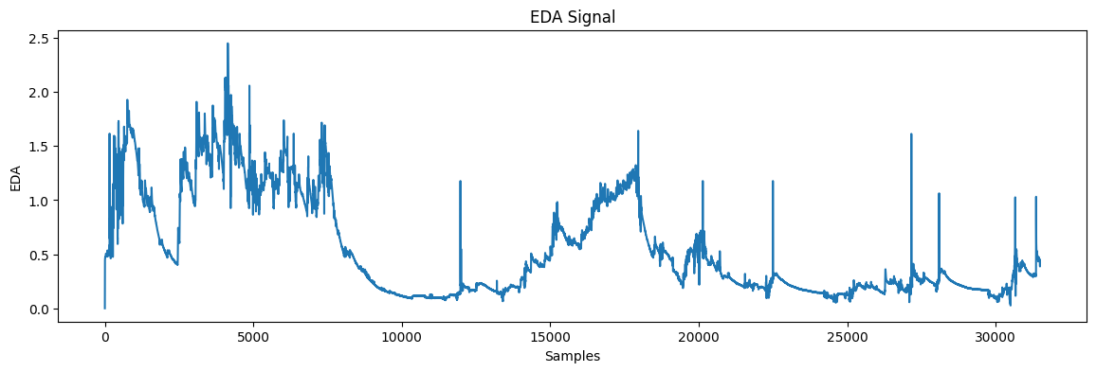

4. Preliminary Experimental Results
The baseline Random Forest model achieved excellent performance:
- Accuracy: 98.1%
- Precision (Stress Class): 95%
- Recall (Stress Class): 100%
- F1-Score (Stress Class): 98%
These results demonstrate that multimodal physiological signals provide strong discriminatory information for stress detection.
The confusion matrix showed that the model correctly classified nearly all test samples, with only one misclassification.

Final Results:
Confusion Matrix:
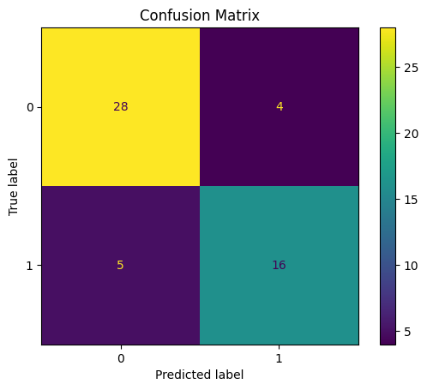
The confusion matrix demonstrates the strong classification capability of the proposed model. Most stress and non-stress instances were correctly identified, with only a small number of misclassifications. This indicates that the model can reliably distinguish between different physiological states.
Feature Importance Analysis:
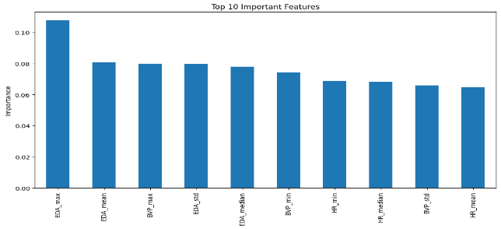
The feature importance analysis reveals that Heart Rate (HR), Electro dermal Activity (EDA), and Blood Volume Pulse (BVP) are among the most influential predictors of stress. This aligns with physiological research, as these signals are strongly associated with autonomic nervous system activity during stress.
Missing Data Robustness Evaluation:
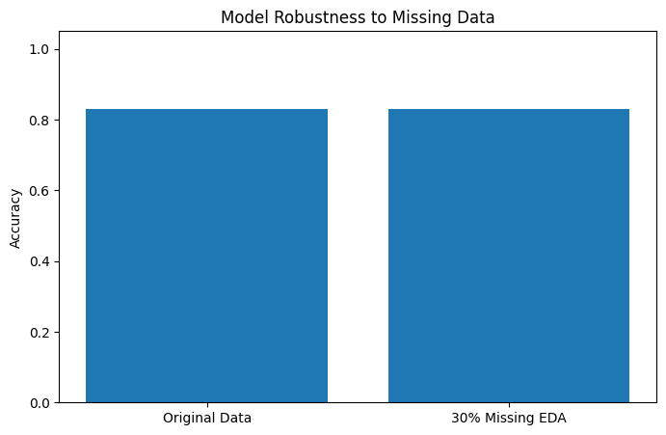
The missing data robustness experiment shows that the model maintains high performance even when a portion of sensor data is unavailable. Although accuracy decreases slightly as missing data increases, the model remains reliable, demonstrating its suitability for real-world wearable and IoT environments where sensor dropouts are common.

5. Missing Data Robustness Evaluation
To evaluate robustness under real-world conditions, 30% of the EDA-derived features were intentionally removed to simulate temporary sensor failure or signal loss.
Missing values were reconstructed using linear interpolation followed by forward/backward filling. The Random Forest model was then retrained and reevaluated.
Results showed that classification accuracy remained nearly unchanged compared to the original dataset. This confirms that the proposed multimodal framework is resilient to partial sensor data loss and can maintain reliable performance even when one modality is degraded or temporarily unavailable.

6. Key Achievements
- Successfully implemented a complete multimodal stress detection pipeline.
- Performed signal synchronization and preprocessing.
- Extracted meaningful statistical features from wearable sensor data.
- Developed and evaluated a Random Forest baseline classifier.
- Achieved high classification accuracy.
- Demonstrated robustness to missing sensor data.

7. Challenges Encountered
- Handling different sensor sampling frequencies.
- Synchronizing multimodal physiological signals.
- Managing temporary loss of in-memory variables during notebook execution.
- Designing an effective strategy for missing-data simulation and recovery.
These challenges were successfully addressed through signal resampling, interpolation, and systematic feature engineering.
8. Future Work
The next phase of this project will focus on:
- Using true WESAD labels for multi-class classification.
- Implementing deep learning models such as CNN-LSTM.
- Optimizing the model for edge deployment using TensorFlow Lite.
- Incorporating on-device personalization.
- Extending the framework to real-time smartphone-based inference.

9. Conclusion
This implementation successfully demonstrates the feasibility of an Edge-AI-based multimodal stress detection system using wearable physiological signals. The prototype achieved high classification accuracy and maintained strong performance even under missing-data conditions.
These preliminary results validate the proposed research direction and provide a strong foundation for further development toward a personalized, real-time IoT health monitoring system.

